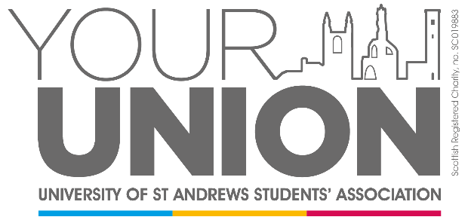

**Students’ Association - External Speaker Agreement**

The Students’ Association provides opportunities to expand students’ experiences and skills outside their traditional academic activities. This includes facilitating debate and Freedom of Speech, whilst providing a safe space for our students and wider community. We request that all speakers and attendees are respectful of the views of others, as well as the laws that protect people from intimidation, discrimination, and harassment.

By attending a Students’ Association event you are agreeing to uphold our policies and procedures regarding Freedom of Speech, Zero Tolerance, and Equality and Diversity.

For further information, please refer to:

* Our [Zero Tolerance Policy](https://www.yourunion.net/about/policies/zero-tolerance/)
* Our [Equality and Diversity Policy](https://www.yourunion.net/pageassets/representation/councils/J19-4-Motion-for-the-adoption-of-an-Equality-and-Diversity-Policy.pdf)

By signing this agreement, you confirm you have read our Zero Tolerance Policy and Equality and Diversity Policy and agree to uphold them during your visit for the event.