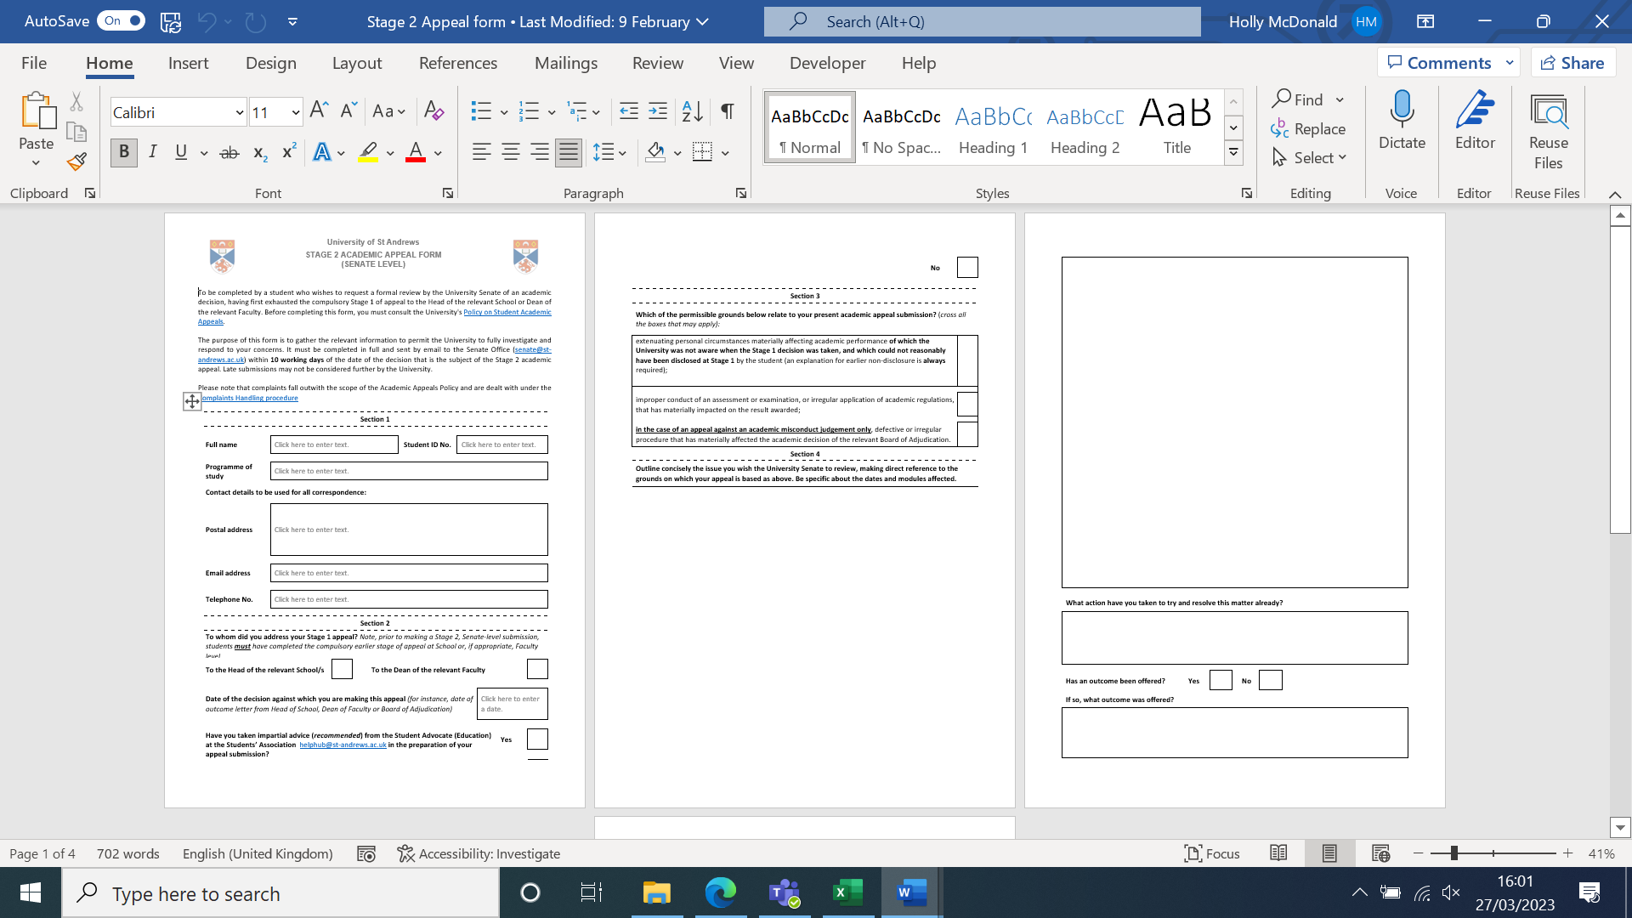

Type in the date of your Stage 1 Appeal outcome letter.

Type an ‘X; in the appropriate box to say who you sent your Stage 1 Appeal to.

Type in your name.

Type in your phone number.

Type in your St Andrews email address.

Include your contact address, preferably where you live during term time if appealing during term time.

Or type in the safest address that you would like to be used.

Type in your student ID/matriculation number.

Type in your programme (e.g. BSc (Hons) Psychology).



Type an ‘X’ in the appropriate box to say if you have or have not sought advice from the Students’ Association HelpHub.

Type an ‘X’ in the appropriate box to say why you are appealing.



Describe any outcomes you were offered when you have tried to resolve the situation previously (e.g., Leave of Absence, moved to a different degree type or pathway).

Refer to specific evidence submitted (e.g. Stage 1 outcome letter, email communication, letter from doctor, prescription evidence).

Type an ‘X’ in the box as appropriate to say if an outcome has been offered when you’ve tried to resolve the situation up to now.

Outline any steps taken already, including any conversations you’ve had with relevant staff as well as your Stage 1 appeal (with dates and key information).

Refer to specific evidence submitted (e.g. Stage 1 appeal form, email communication).

Explain what happened, why you are appealing, and explain in as much detail as can about extenuating circumstances and/or the improper conduct of assessment or academic rules.

Give dates where you can, along with module codes and titles.

Refer to specific evidence submitted (e.g. medical evidence, evidence from your module etc).

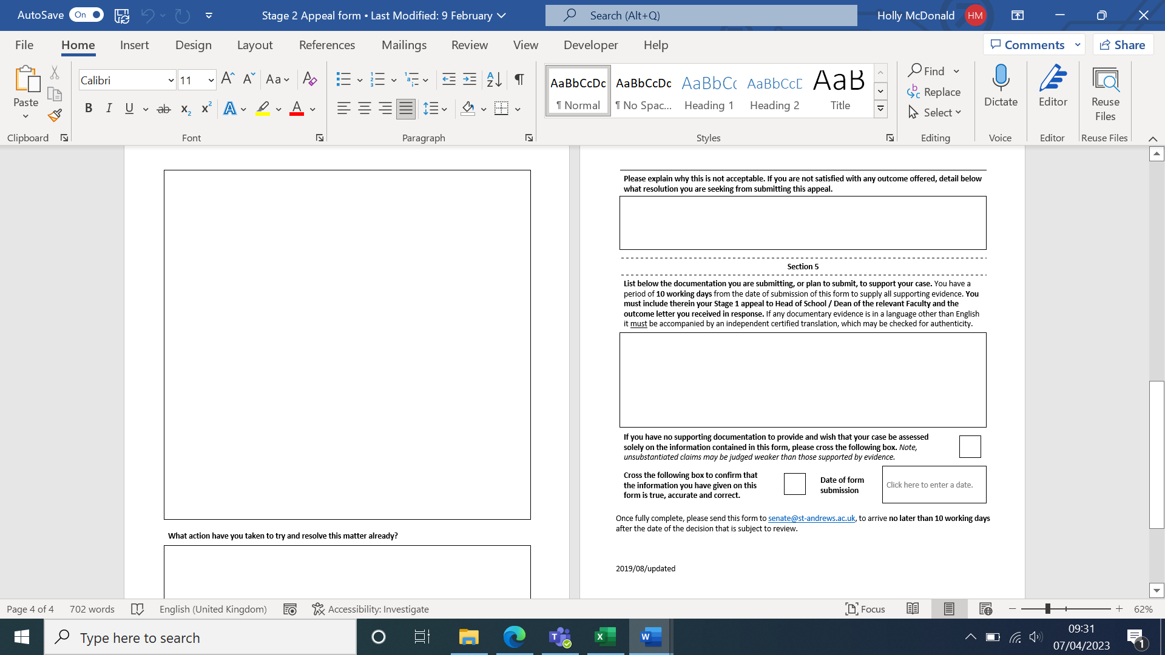

Type an ‘X’ to say that you’ve told the truth.

List the evidence you are submitting in your appeal (e.g. 1.Stage 1 Appeal outcome letter (date), 2. Letter from Doctor (date).

Explain why you feel any outcome you have received so far has not satisfied the issue (e.g. it did not take into account certain factors or information).

Describe the outcome you are hoping for by making this Stage 2 appeal (e.g. being able to complete your desired degree pathway).

Type in the date of the day when you will send your appeal to Senate.

Type an ‘X’ in the box if you are not submitting evidence.

Send the form along with all your evidence **(in Word or PDF only)** to **senate@st-andrews.ac.uk.**